How to fix broken protection groups & recovery plans in the vblocks:

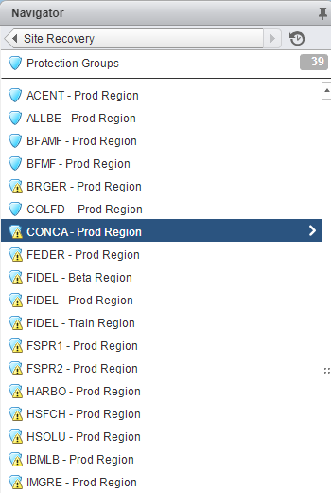

1. Select the protection group you want to fix and view it’s virtual machines, make a note of the VM names in this group as well as its actual protection group name (exp. CONCA – Prod Region)
   1. 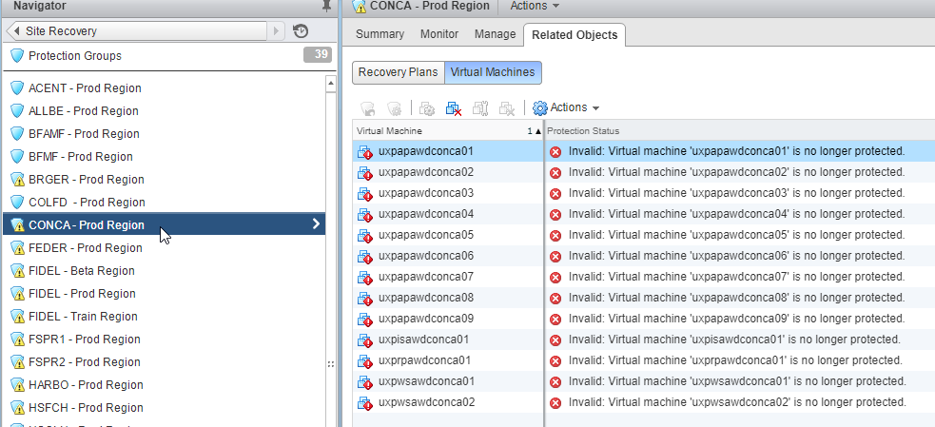
2. Delete the protection group
   1. 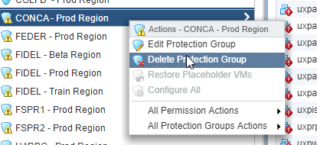
3. Once deleted, now you need to create a new protection group
   1. 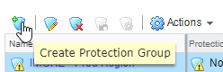
   2. Give it is original name and make sure you select the correct vCenters (vblock01/vblock02)
      1. 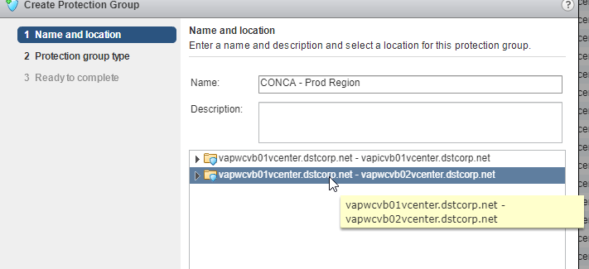
   3. Select the direction of path and select “Individual VMs”
      1. 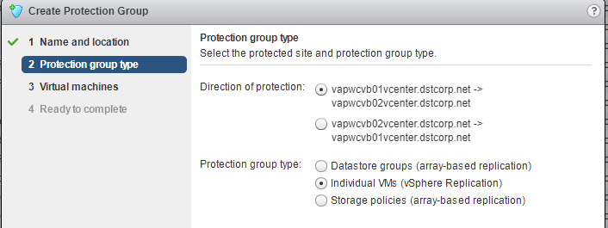
   4. Do a search for all of the VMs that you notated earlier from the old protection group and select them
      1. 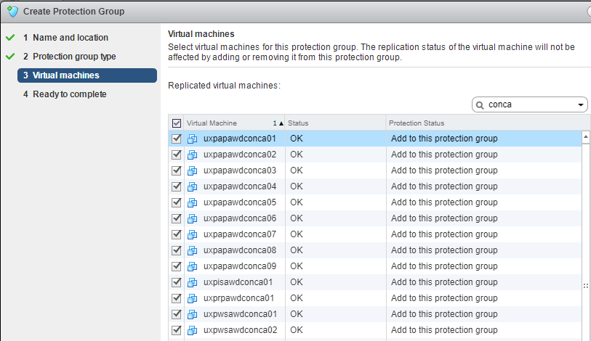
   5. Select finish.
4. Now that you have created the new protection group it is time to create the new recovery plan.
   1. Delete the old recovery plan (Make note of the original recovery plan name)
      1. 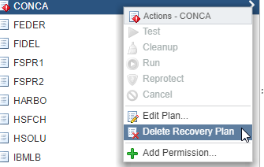
   2. Select create new recovery plan
      1. 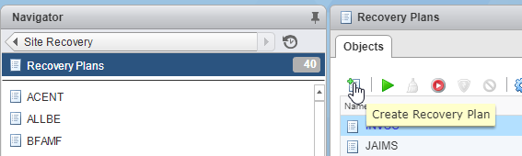
   3. Give it the correct (the name of the original) and select the correct vCenters
      1. 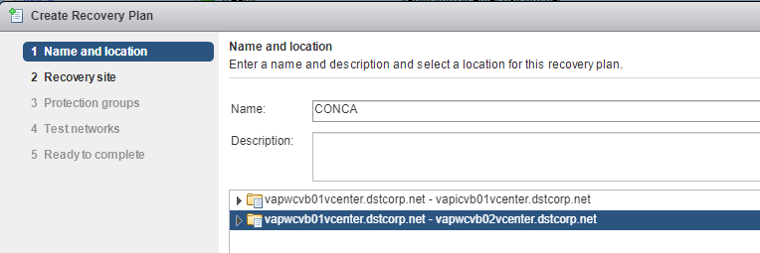
   4. Select the recovery site
      1. 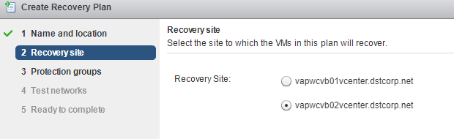
   5. Select you’re newly created protection group
      1. 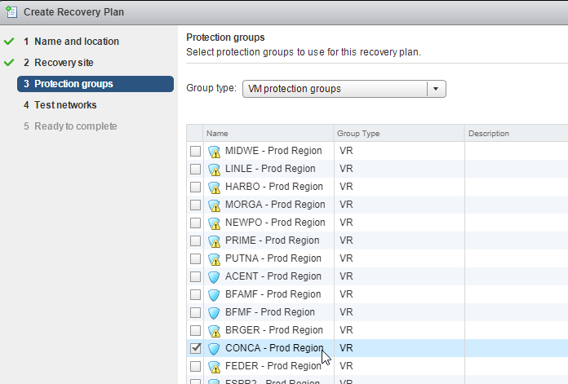
   6. Leave all the test networks set to auto
      1. 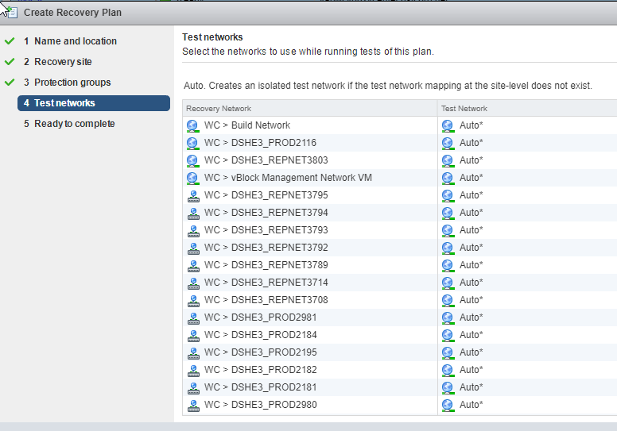
5. Select Finish